.Net Core

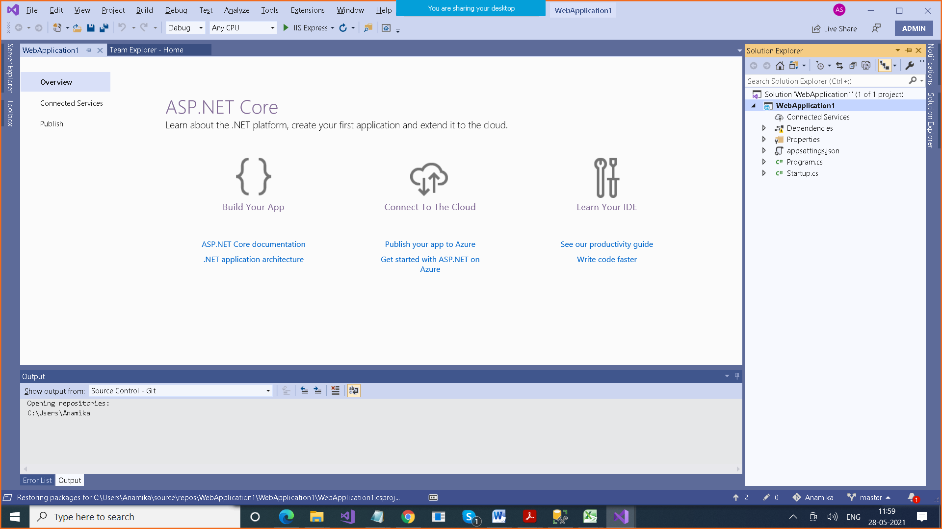

Net Framework

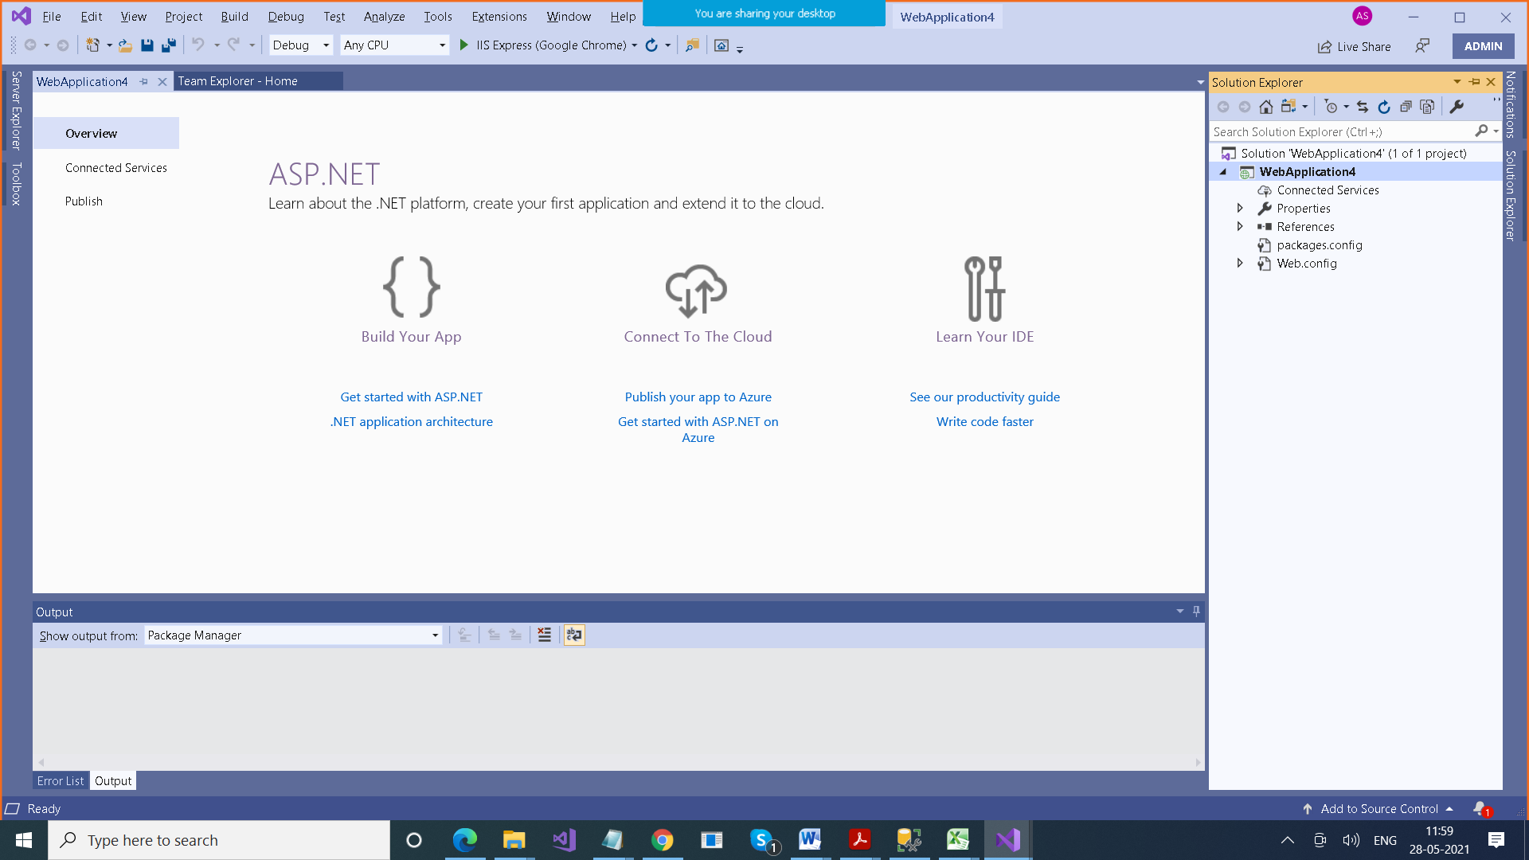

**.Net Core > Startup.cs**

**Program.cs**

**Editing .csproj file is easy**

**.Net Framework > References folder , which contains some packages coming by default**

**How do we edit .csproj file**

**Unload project**

**Edit .csproj file**

**Reload project**